THE FISH’S WISHES

E

F
G
STAGE
H
A
B
C
D

A: Blanket
B: Chair
C: Ladder
D: Cabinet
E: Small table
F: Backdrop
G: Broom hanging from string running through two pullies terminating with a robe on hanger:

G
H: Pot hanging from ceiling on a string and hook.

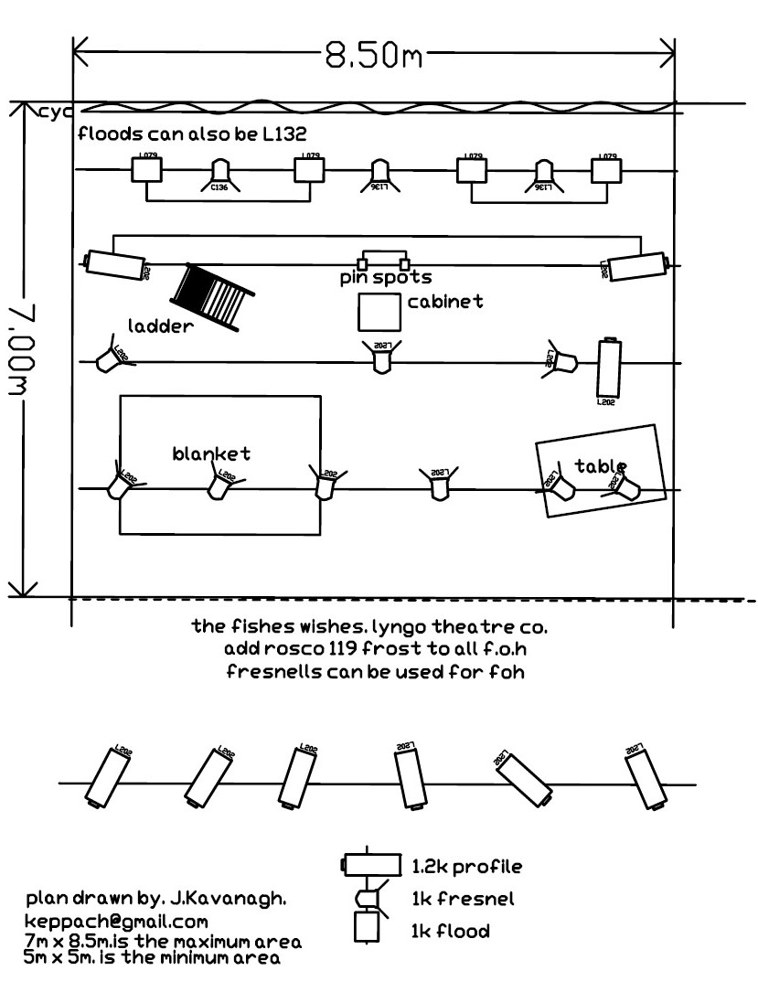

TECHNICAL SPECIFICATIONS FOR “THE FISH’S WISHES”

The show requires a space of 5x5 metres and can play for up to 250 people. A raised stage would be best but is not essential.

A CD or mini-disc player is required for the music.

One pulley is suspended from the lighting rig, carrying a maximum of 1 kilogram weight (please see tech-sketches above).

If you would like to speak to a technician who has worked on the show please contact James at the Half Moon Young People’s Theatre, London, 02077098911

A small naked flame is used during the show.

All scenery is flameproofed

Get in time is two hours and get out is an hour.

